**WITH NOISE AND WITHOUT FILTER**

**Image set:**

|  |
| --- |
| **Image 1:-0.1 % Noise** |

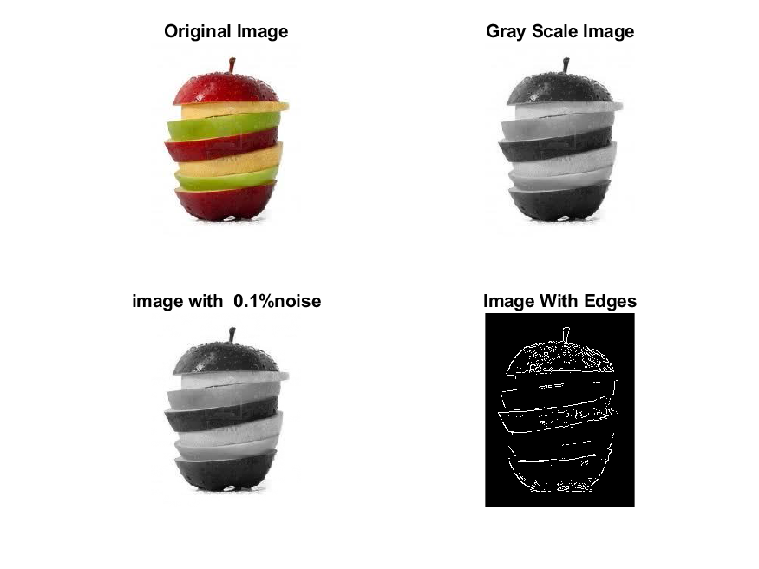

**Image 2:-10 % Noise**

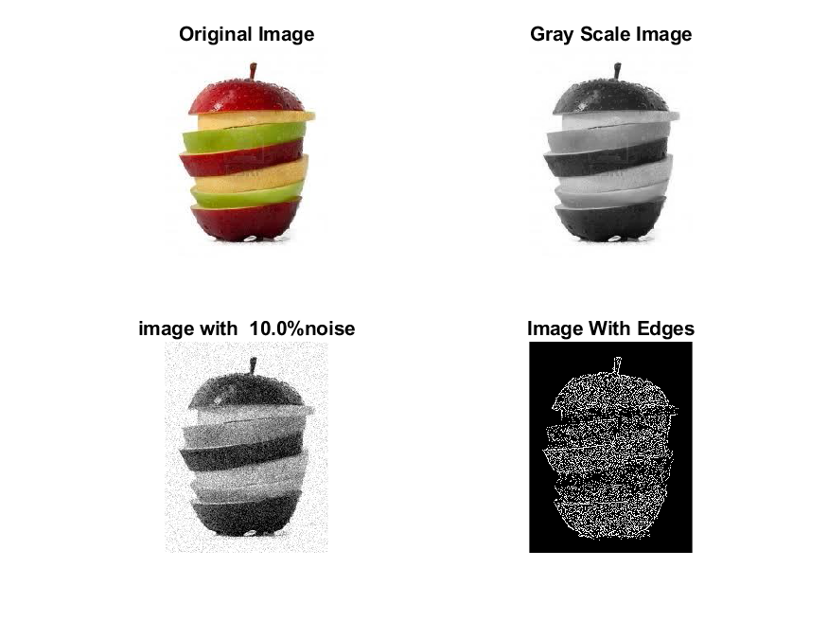

**Image 3:-20 % Noise**

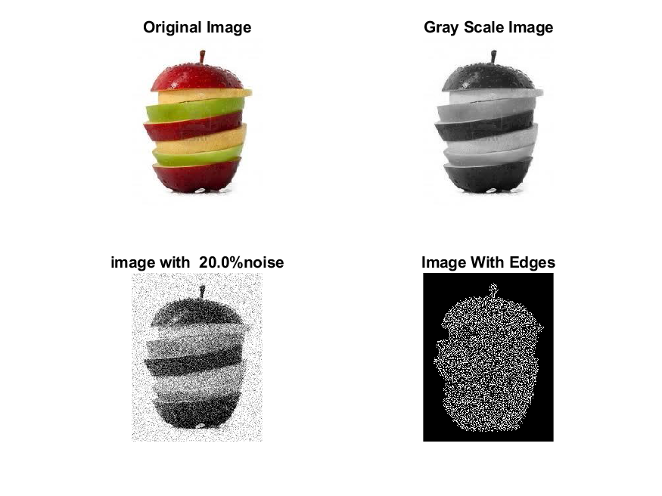

**Image 4:-30 % Noise**

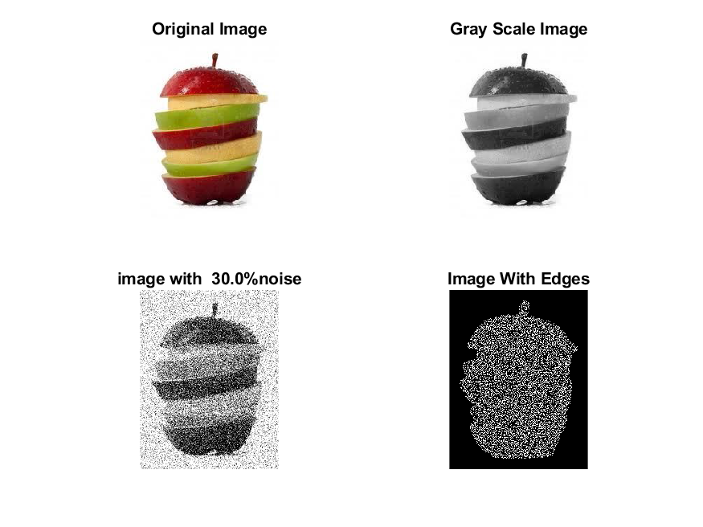

|  |
| --- |
| **Image 5:-40 % Noise** |

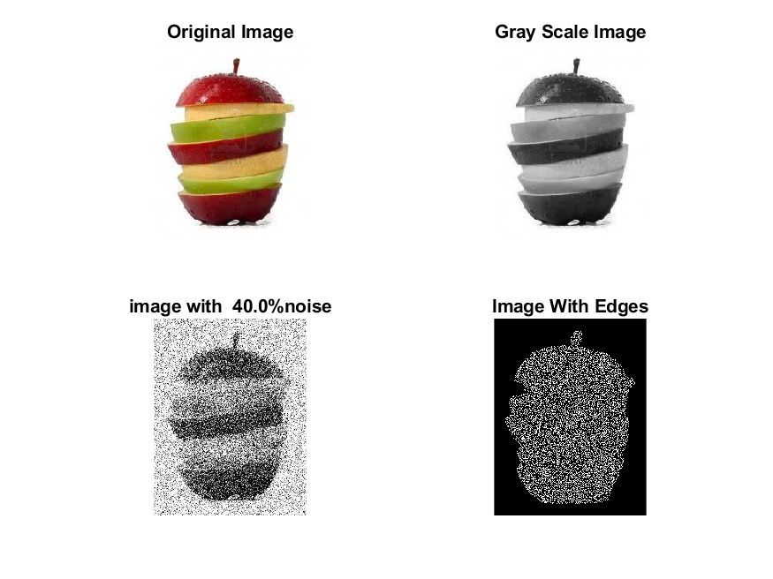

**Image 6:-50 % Noise**

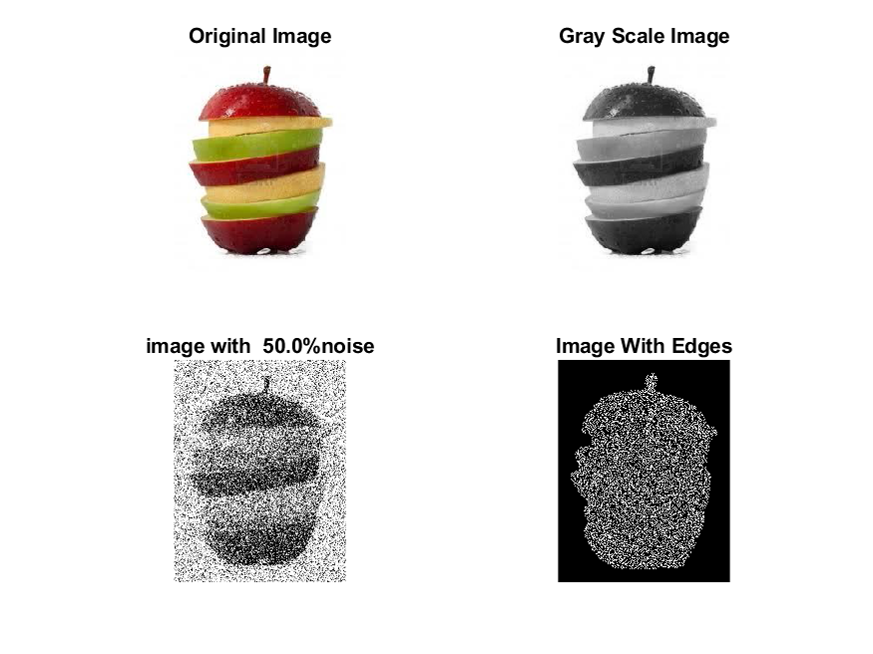

**Image 7:-60 % Noise**

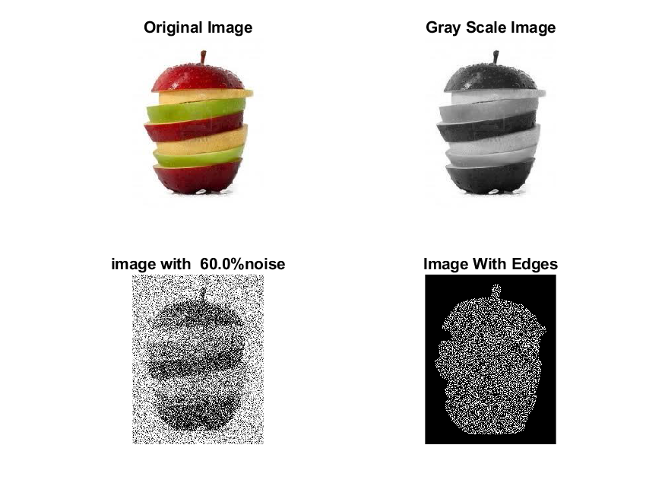

**Image 8:-70 % Noise**

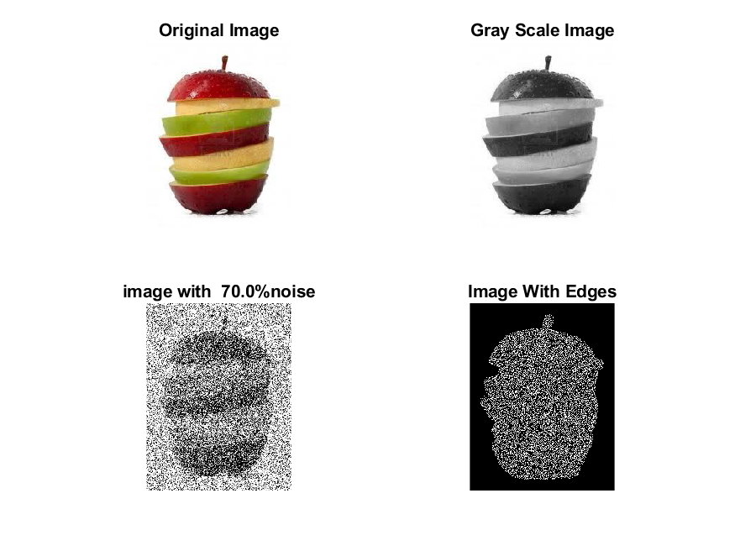

**Image 9:-80 % Noise**

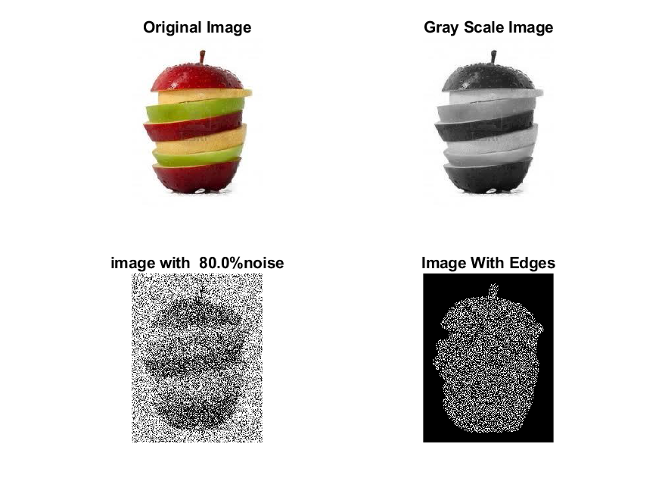

**DATA FILES**

**Image 1:-Noise0.1**

Original image ideal values:

IM1 image entropy:2.699556e-01

IM1 image mean:0.046183

Ground truth image entropy:0.596365

Ground truth image mean:0.144680

entropy between imt and im1 :0.555932

MSE between imt and im1 :0.160406

Average Difference between imt and im1 :0.098497

Maximum Difference between imt and im1 :1.000000

True Positive values:765.000000

False Positive values: 1555.000000

True Negative values:41412.000000

False Negative values:6503.000000

Accuracy value: 0.839594

F Measure values:0.159574

Peak Signal-to Noise Ration value: 7.947791

Signal-to Noise Ration value: -4.959269

percentage of pixels that were correctly detected (Pco): 0.105256

The percentage of pixels that were not detected (Pnd):0.894744

the percentage of false alarm: (Pfa):0.213952

Euclidean Distance Value :9.624046

**Image 2:-Noise10**

Original image ideal values:

IM1 image entropy:6.034144e-01

IM1 image mean:0.147447

Ground truth image entropy:0.596365

Ground truth image mean:0.144680

entropy between imt and im1 :0.481769

MSE between imt and im1 :0.210909

Average Difference between imt and im1 :-0.002767

Maximum Difference between imt and im1 :1.000000

True Positive values:2040.000000

False Positive values: 5367.000000

True Negative values:37600.000000

False Negative values:5228.000000

Accuracy value: 0.789091

F Measure values:0.278024

Peak Signal-to Noise Ration value: 6.759054

Signal-to Noise Ration value: 0.082274

percentage of pixels that were correctly detected (Pco): 0.275415

The percentage of pixels that were not detected (Pnd):0.705819

the percentage of false alarm: (Pfa):0.724585

Euclidean Distance Value :26.582925

**Image 3:-Noise20**

Original image ideal values:

IM1 image entropy:6.723833e-01

IM1 image mean:0.176510

Ground truth image entropy:0.596365

Ground truth image mean:0.144680

entropy between imt and im1 :0.458849

MSE between imt and im1 :0.225480

Average Difference between imt and im1 :-0.031830

Maximum Difference between imt and im1 :1.000000

True Positive values:2404.000000

False Positive values: 6463.000000

True Negative values:36504.000000

False Negative values:4864.000000

Accuracy value: 0.774520

F Measure values:0.297986

Peak Signal-to Noise Ration value: 6.468915

Signal-to Noise Ration value: 0.863618

percentage of pixels that were correctly detected (Pco): 0.271118

The percentage of pixels that were not detected (Pnd):0.548551

the percentage of false alarm: (Pfa):0.728882

Euclidean Distance Value :26.148100

**Image 4:-Noise30**

Original image ideal values:

IM1 image entropy:6.803252e-01

IM1 image mean:0.180113

Ground truth image entropy:0.596365

Ground truth image mean:0.144680

entropy between imt and im1 :0.459682

MSE between imt and im1 :0.229601

Average Difference between imt and im1 :-0.035433

Maximum Difference between imt and im1 :1.000000

True Positive values:2391.000000

False Positive values: 6657.000000

True Negative values:36310.000000

False Negative values:4877.000000

Accuracy value: 0.770399

F Measure values:0.293087

Peak Signal-to Noise Ration value: 6.390265

Signal-to Noise Ration value: 0.951377

percentage of pixels that were correctly detected (Pco): 0.264257

The percentage of pixels that were not detected (Pnd):0.539014

the percentage of false alarm: (Pfa):0.735743

Euclidean Distance Value :25.462755

**Image 5:-Noise40**

Original image ideal values:

IM1 image entropy:6.904476e-01

IM1 image mean:0.184791

Ground truth image entropy:0.596365

Ground truth image mean:0.144680

entropy between imt and im1 :0.459426

MSE between imt and im1 :0.234120

Average Difference between imt and im1 :-0.040111

Maximum Difference between imt and im1 :1.000000

True Positive values:2395.000000

False Positive values: 6888.000000

True Negative values:36079.000000

False Negative values:4873.000000

Accuracy value: 0.765880

F Measure values:0.289408

Peak Signal-to Noise Ration value: 6.305622

Signal-to Noise Ration value: 1.062734

percentage of pixels that were correctly detected (Pco): 0.257998

The percentage of pixels that were not detected (Pnd):0.524938

the percentage of false alarm: (Pfa):0.742002

Euclidean Distance Value :24.837372

**Image 6:-Noise50**

Original image ideal values:

IM1 image entropy:6.884828e-01

IM1 image mean:0.183876

Ground truth image entropy:0.596365

Ground truth image mean:0.144680

entropy between imt and im1 :0.456536

MSE between imt and im1 :0.231412

Average Difference between imt and im1 :-0.039196

Maximum Difference between imt and im1 :1.000000

True Positive values:2440.000000

False Positive values: 6797.000000

True Negative values:36170.000000

False Negative values:4828.000000

Accuracy value: 0.768588

F Measure values:0.295668

Peak Signal-to Noise Ration value: 6.356134

Signal-to Noise Ration value: 1.041160

percentage of pixels that were correctly detected (Pco): 0.264155

The percentage of pixels that were not detected (Pnd):0.522681

the percentage of false alarm: (Pfa):0.735845

Euclidean Distance Value :25.449893

**Image 7:-Noise60**

Original image ideal values:

IM1 image entropy:6.976812e-01

IM1 image mean:0.188195

Ground truth image entropy:0.596365

Ground truth image mean:0.144680

entropy between imt and im1 :0.450652

MSE between imt and im1 :0.232109

Average Difference between imt and im1 :-0.043515

Maximum Difference between imt and im1 :1.000000

True Positive values:2531.000000

False Positive values: 6923.000000

True Negative values:36044.000000

False Negative values:4737.000000

Accuracy value: 0.767891

F Measure values:0.302715

Peak Signal-to Noise Ration value: 6.343079

Signal-to Noise Ration value: 1.142007

percentage of pixels that were correctly detected (Pco): 0.267717

The percentage of pixels that were not detected (Pnd):0.501058

the percentage of false alarm: (Pfa):0.732283

Euclidean Distance Value :25.807008

**Image 8:-Noise70**

Original image ideal values:

IM1 image entropy:6.952401e-01

IM1 image mean:0.187041

Ground truth image entropy:0.596365

Ground truth image mean:0.144680

entropy between imt and im1 :0.453698

MSE between imt and im1 :0.232826

Average Difference between imt and im1 :-0.042361

Maximum Difference between imt and im1 :1.000000

True Positive values:2484.000000

False Positive values: 6912.000000

True Negative values:36055.000000

False Negative values:4784.000000

Accuracy value: 0.767174

F Measure values:0.298128

Peak Signal-to Noise Ration value: 6.329690

Signal-to Noise Ration value: 1.115281

percentage of pixels that were correctly detected (Pco): 0.264368

The percentage of pixels that were not detected (Pnd):0.509153

the percentage of false alarm: (Pfa):0.735632

Euclidean Distance Value :25.472803

**Image 9:-Noise80**

Original image ideal values:

IM1 image entropy:6.934644e-01

IM1 image mean:0.186205

Ground truth image entropy:0.596365

Ground truth image mean:0.144680

entropy between imt and im1 :0.457887

MSE between imt and im1 :0.234577

Average Difference between imt and im1 :-0.041525

Maximum Difference between imt and im1 :1.000000

True Positive values:2419.000000

False Positive values: 6935.000000

True Negative values:36032.000000

False Negative values:4849.000000

Accuracy value: 0.765423

F Measure values:0.291060

Peak Signal-to Noise Ration value: 6.297137

Signal-to Noise Ration value: 1.095824

percentage of pixels that were correctly detected (Pco): 0.258606

The percentage of pixels that were not detected (Pnd):0.518388

the percentage of false alarm: (Pfa):0.741394

Euclidean Distance Value :24.897802